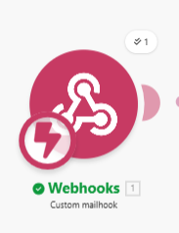
Step 1: Webbook

The Trigger (Custom Mailhook)
- Action: A unique Webhook URL (ebra988...) acts as a dedicated intake for all incoming RFQ emails.
- Data Captured: The system automatically captures the email subject, sender details, raw body text, and any attached files.
- Goal: This ensures the automation starts the second an email is received, with no manual intervention.
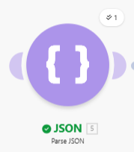

Step 2: JSON

Structured Data Extraction (JSON Parser)
- Action: The raw email text is parsed into structured variables like item, quantity, contact_name, and location.
- Design Note (Why no OpenAI?):
  - Cost Efficiency: Built-in JSON parsing is free in Make.com, whereas OpenAI requires per-token API fees.
  - Data Integrity: JSON ensures 100% precision, avoiding the "hallucinations" or format changes often seen with AI models.
  - Performance: Avoiding external AI calls allows the entire scenario to run in just 4 seconds.
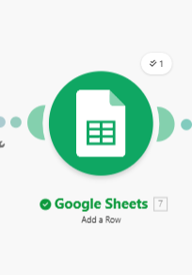

Step 3: Google Sheets

Database Logging
- Action: Extracted data is logged into the RFQ Logs spreadsheet.
- Localized Time: A custom formula formatDate(now; YYYY-MM-DD hh:mm A; Asia/Riyadh) was used to ensure every log matches Riyadh local time instead of UTC.
- Goal: Provides the sales team with a real-time, organized database of all leads.

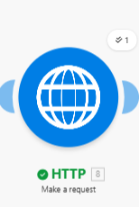
Step 4: HTTP Request

CRM Mock Integration
- Action: A POST request sends the client's information to a mock CRM endpoint.
- Payload: The system sends a formatted JSON body containing the Opportunity Name, Product, and Quantity.
- Goal: Simulates how the RFQ data would automatically populate a sales pipeline like HubSpot or Salesforce.
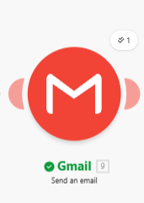

Step 5: Gmail

Bilingual Auto-Reply
- Action: A confirmation email is automatically sent back to the client's address.
- Content: The email is professionally drafted in Arabic and English using Raw HTML formatting for a clean look.
- Goal: Provides immediate customer engagement and professional brand representation.

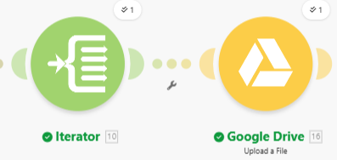
Step 6: Iterator & Drive

Attachment Management
- Action: An Iterator separates each file attached to the email.
- Archiving: Each file is then uploaded to a specific Google Drive folder named RFQ Attachments.
- Goal: Ensures that technical drawings or spec sheets are never lost and are easily accessible to the team.

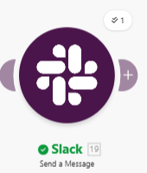
Step 7: Slack

Internal Team Notification
- Action: A final notification is sent to the #rfq-alerts Slack channel.
- Message: The alert includes the client's name and the item they requested for instant visibility.
- Goal: keeps the entire sales team updated without them having to check their email manually.

Troubleshooting & Error Log

- JSON Data Error: Fixed hidden HTML tags in Gmail by switching the test email to Plain Text mode.
- Slack Error (no_text): Resolved the "no_text (200)" error by adding descriptive labels to the data pills in the message field.

ATTACH SCREENSHOT

Step 1: Webbook
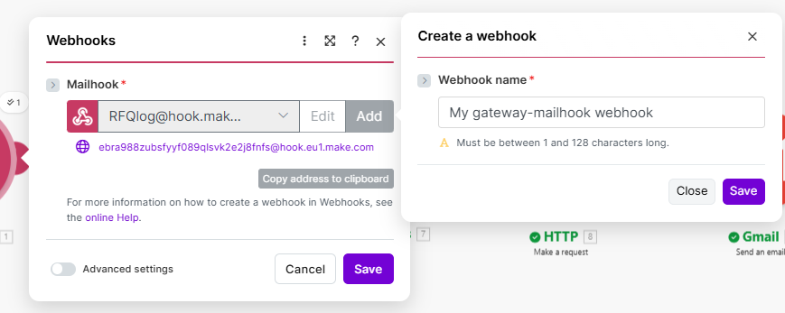

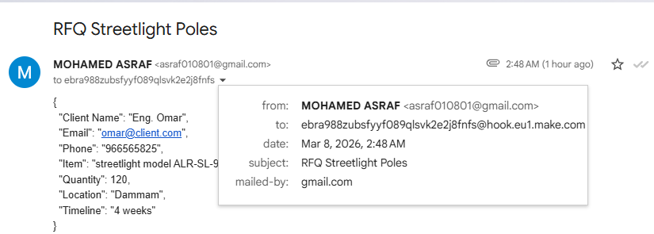

Step 2: JSON
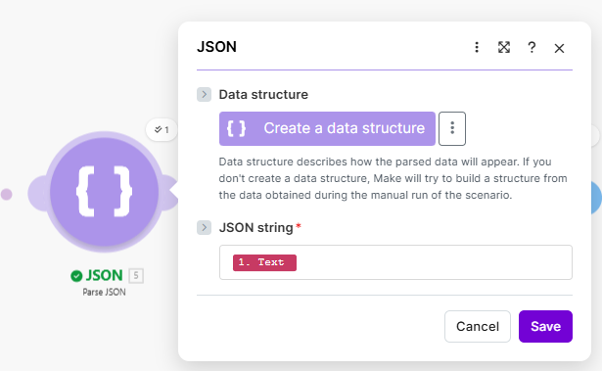

Step 3: Google Sheets
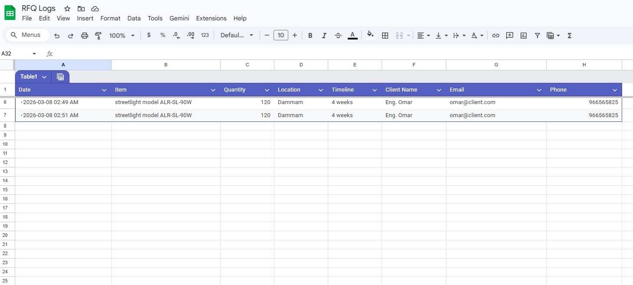

Step 4: HTTP Request
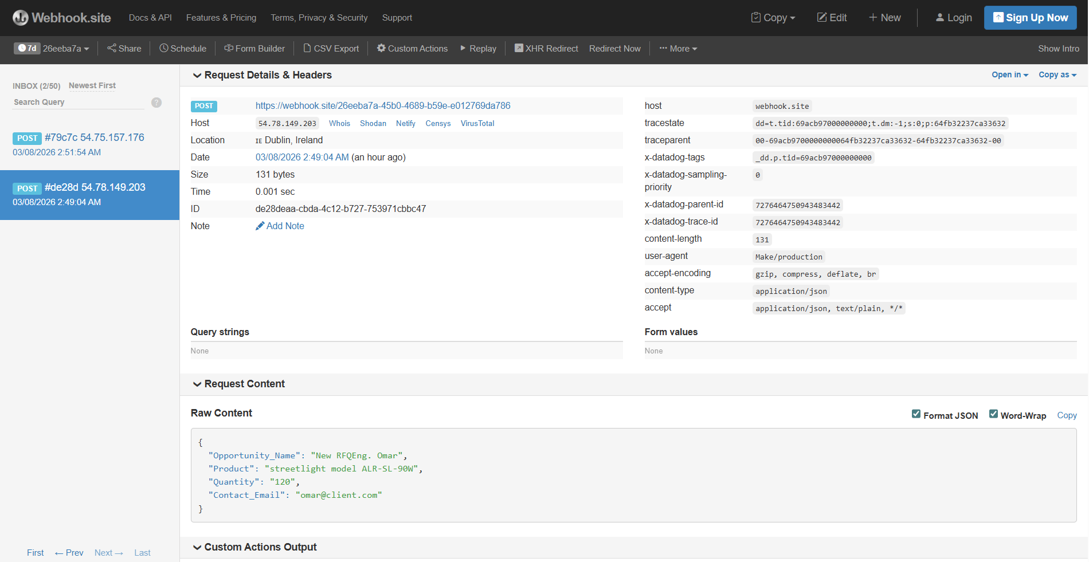

Step 5: Gmail
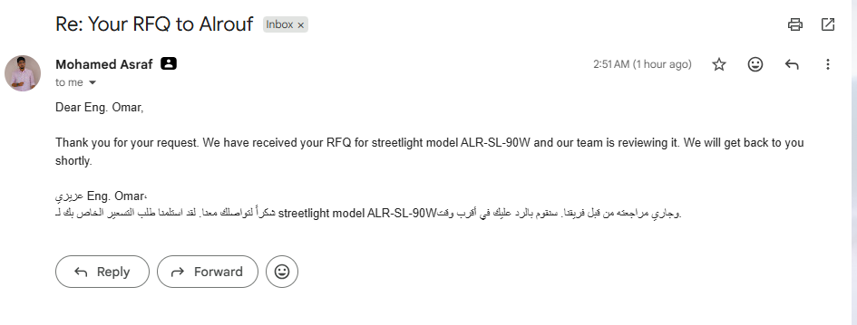

Step 6: Iterator & Drive
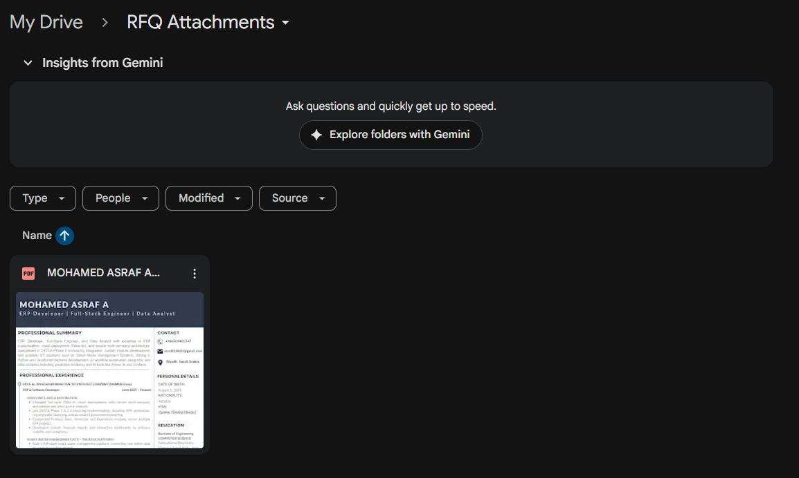

Step 7: Slack
